Lab No-05

Lab Report Name: Connecting a database (MySQL) with Linux

Objectives:

- Install mysql on Ubuntu
- login into mysql
- Create database table.
- Insert data into table.
- Describe table.
- Alter table.
- Modify table.
- Drop data from table.
- Update data of table.
- Where and delete operation.

1.Install mysql on ubuntu: To install mysql on ubuntu we need to write the following commands on linux terminal.

sudo apt-get update
sudo apt-get install mysql-server
mysql_secure_installation

2.Login into mysql: For login into mysql after installation we need to write the following commands in linux terminal.
Sudo mysql
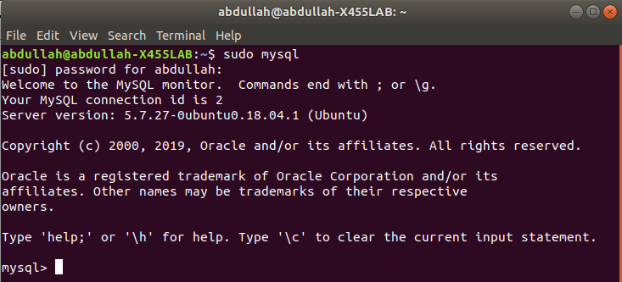
3.Create and show databases:To show databases we need to write a command “show databases”.to create database we need to write “create database databaseName”.
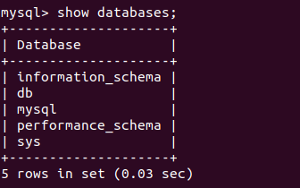

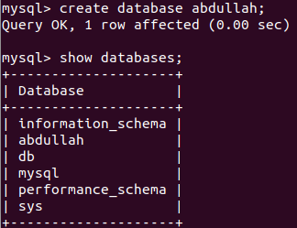

4.Create database table:In mysql database table is created by using below command.
Create table tablename(attributes name type)
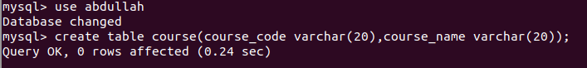
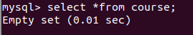

5.Insert Data into table: Data is inserted into table by using following commands:
insert into table_name values(“value1”,”value2...”);
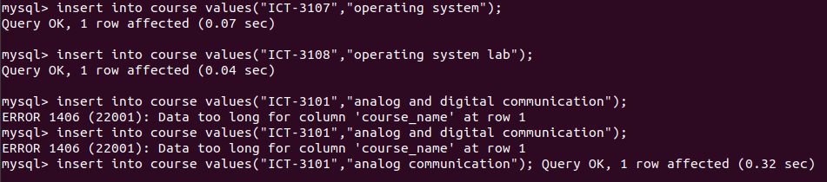
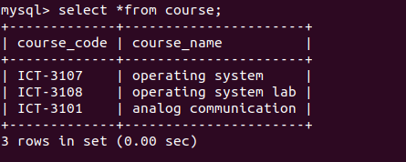

6.Describe table:list the contents of the table,types of attribute.


7.Alter table:we can change our table contents by alter commands.Here i Add an extra column credit of integer types.
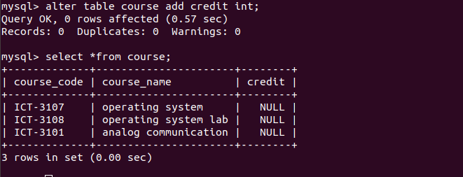

8.Modify table:Change the exitence contents of a table.Here I delete the column credit.
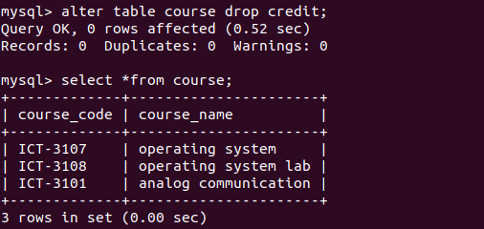
9.Drop data from table:
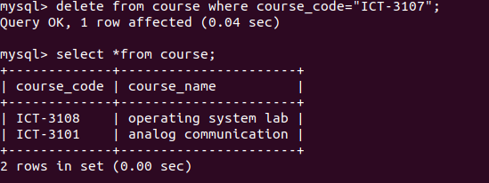
10.Update table:
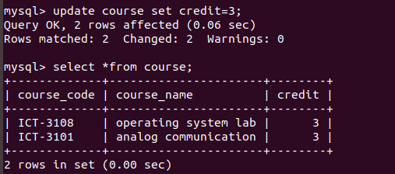

11.where and Delete operations:

